Making CPT configs using LibreCalc (Excel)
- Download&Install LibreOffice (Excel probably is the same, untested) and grepWin.
- Prepare table.ods and folder with a mod, that you want prepare to CPT.
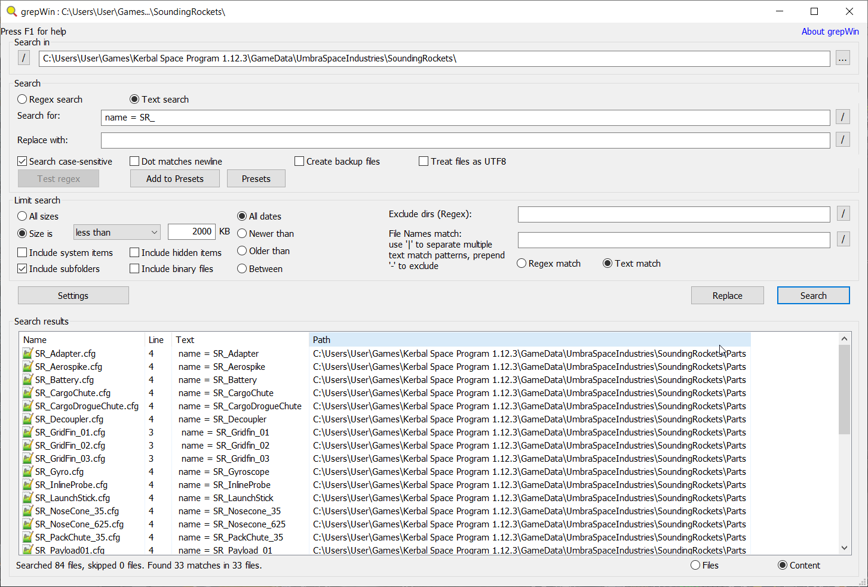
- search in the grepWin in the folder of a mod for a line, with a name of the part, in all files.
In this example name = SR_ is used, SR_ is a prefix, that all parts share in the mod.
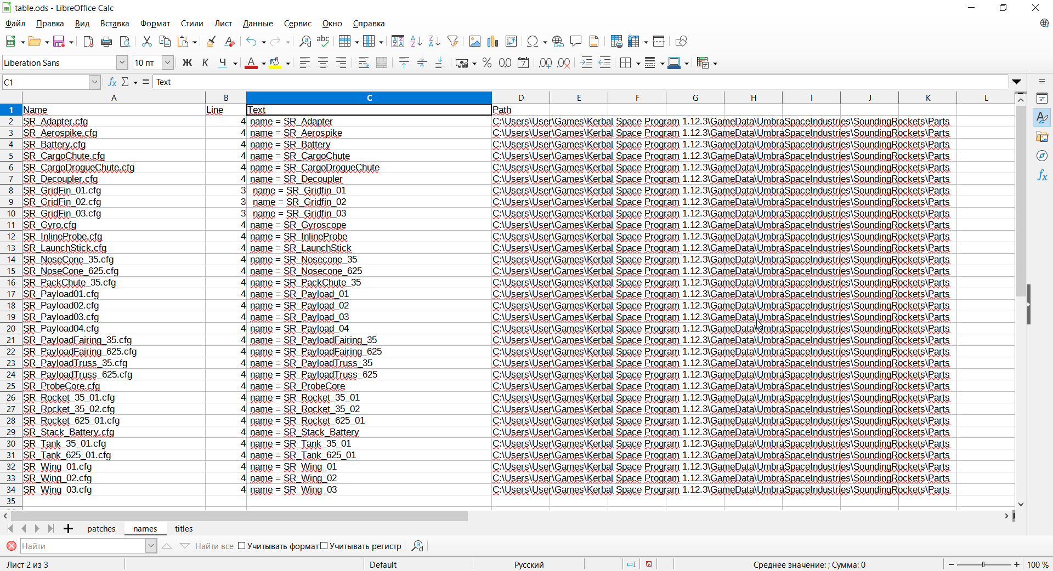
- Copy result in the table.ods in the “names” worksheet:
- remove the name = prefix in the column C, so there would be only the names of the parts.
You could use the find and replace tool of the Calc (Excel)
  - don’t forget about trimming spaces
(regex for find and replace tool: [ ]*$ and ^[ ]*)
- Repeat the same with a titles:
  - search for title = in the GrepWin
  - paste in the “titles” spreadsheet in the table.ods
  - remove the title = prefix and trim spaces
- check that names and titles spreadsheets have the same amount of lines and they are in the same order.
- Switch to “Patches” spreadsheet
- Write name of a mod to A7 cell in the “Patches” spreadsheet
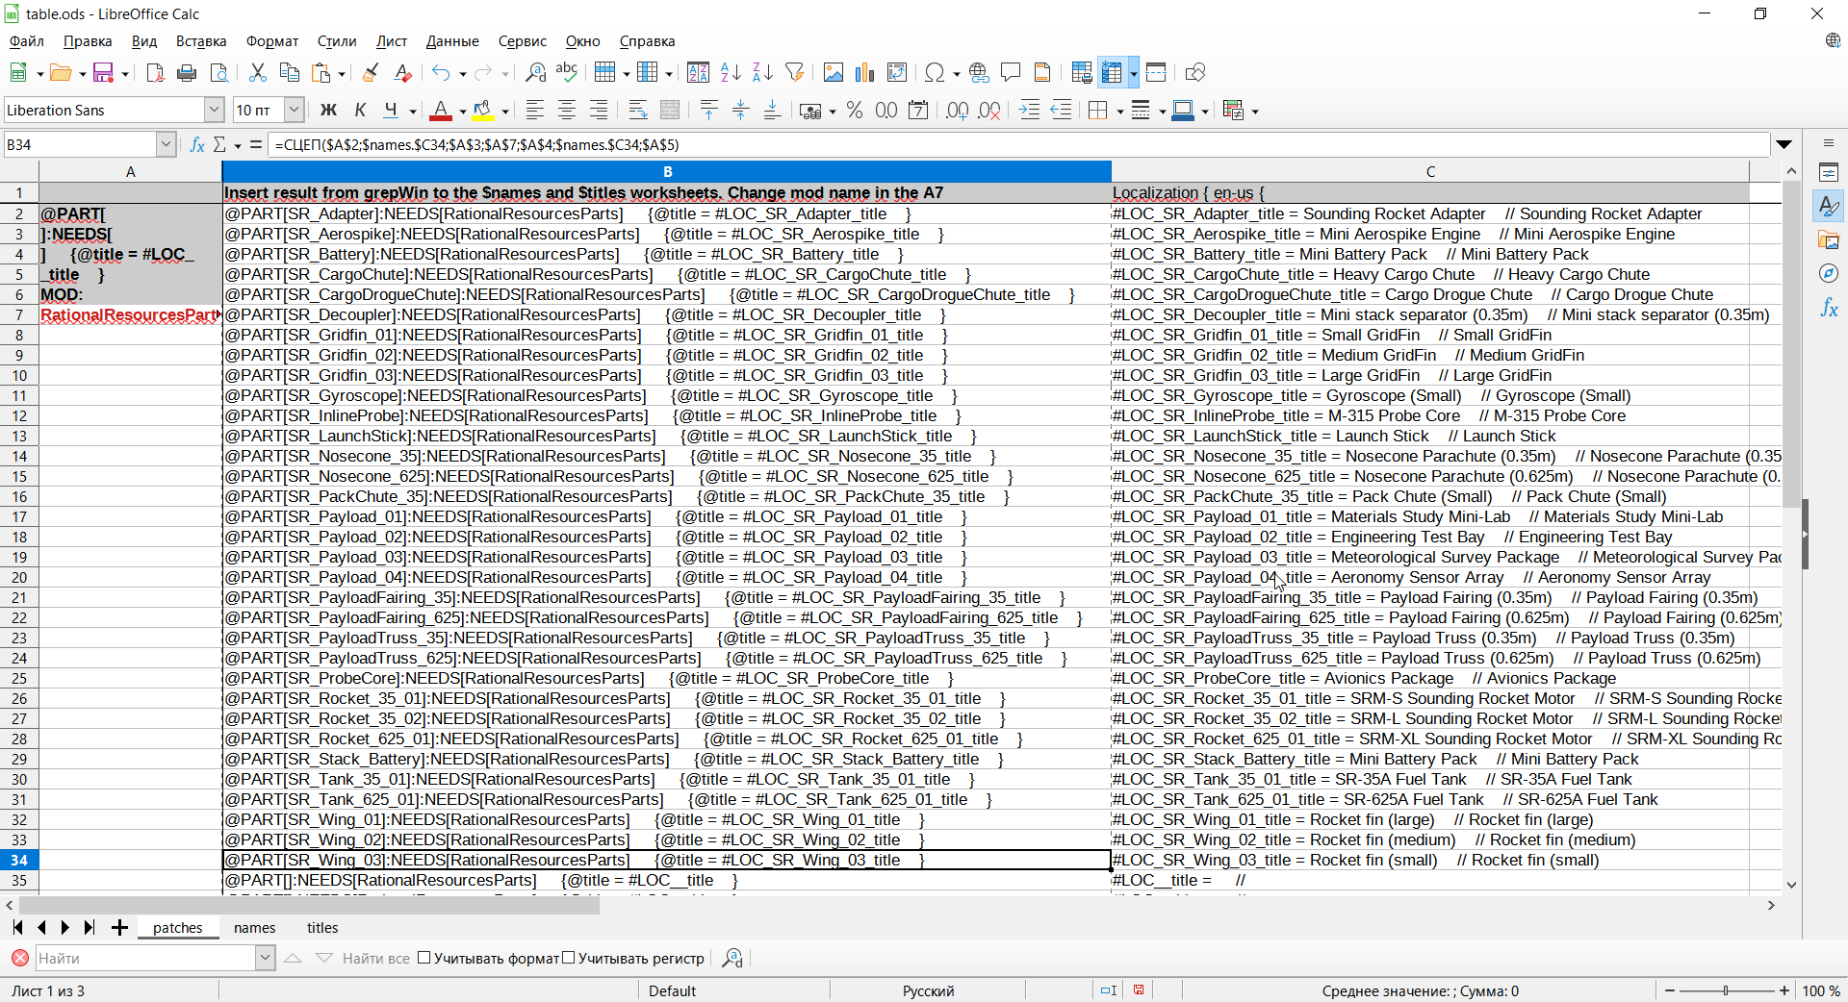
- In the B column you will be having localization MM patches and in the C column a localization configs

